**Global Cloud**

**Managed Services**

**Amazon AWS**

**“AWS-SLB-QCON-PRD”**

**Configuration**

**For User Acceptance : UAT**

**Prepared for**

**ชื่อลูกค้าที่เป็นทางการ**

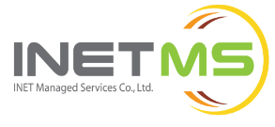

**INET Managed Services Co. Ltd**

1768 Thai Summit Tower, 12th Floor

New Petchaburi Rd, Bangkapi, Huaykwang, Bangkok 10310

Tel: 0-2257-7000 | Fax: 0-2257-1379 |Call Center: 0-2257-7299

**Table of Contents**

**Contents**

**1. General Project Information** 3

**1.1 General Project Information** 3

**1.2 Customer Contact Information** 3

**1.3 INET Contact Information** 3

**2. Microsoft SQL Server’s Minimum Requirement** 4

**2.1 Check Server Machine Specification** 4

**2.1.1 Database Node 1** 4

**2.1.2 Database Node 2** 5

**2.2 Active Directory Server** 5

**3. Database Instance Configuration** 6

**3.1 database node 1** 6

**3.2 database node 2** 6

**4. SQL Server Always on Availability Group Information** 7

**4.1 Availability Replica Information** 7

**4.2 Availability Databases** 7

**5. Monitoring and Management Availability Groups** 8

**5.1 Availability Groups Dashboards** 8

**5.2 Check Status Availability Groups** 9

**5.3 Failover Availability Group (Manual Failover in SSMS)** 11

**6. Test Failover Availability Group** 13

**6.1 Manual failover availability group** 13

**7. Test connect to SQL Server** 15

**7.1 Test connect database by SSMS on THONBURI_DB1** 15

**7.2 Test connect database by SSMS on THONBURI_DB2** 16

**8. Windows Users** 16

**8.1 On AD** 16

**8.2 On Local** 16

**9. Schedule job database** 17

**9.1 Backup, Retention** 17

# **1. General Project Information**

## **1.1 General Project Information**

|  |  |
| --- | --- |
| **Project Name:** | <ชื่อ project หรือชื่อบริษัทลูกค้า> |
| **DBA services:** | <Implementation, Managed Services, Database As A services> |
| **Service Start Date:** | <วันที่ทำการส่งมอบเครื่องให้ลูกค้า> |
| **Service End Date:** | <วันที่สิ้นสุดสัญญา> |
| **Infrastructure:** | <INET’s Nutanix Cloud, INET’s Dell Cloud,… > |
| **DB Product:** | <database software ที่ติดตั้ง เช่น Microsoft SQL Server> |
| **DB Feature/Option:** | <database feature หรือ option ที่ implementเช่น SQL Server Always On |
| **Amount of services:** | <ใส่จำนวน service ที่เราให้บริการ เช่น 1 couple> |

## **1.2 Customer Contact Information**

|  |  |  |
| --- | --- | --- |
| **Customer 1st** | **Name:** | <ชื่อลูกค้าที่ดูแลรับมอบ services> |
| **Phone No:** | <เบอร์ติดต่อลูกค้า>,<อาจะมีมากกว่า 1 เบอร์ได้> |
| **Email:** | <email ติดต่อลุกค้า> |
| **Customer 2nd** | **Name:** | กรณีมี contact ลูกค้ามากกว่า 1 ท่าน |
| **Phone No:** |  |
| **Email:** |  |

## **1.3 INET Contact Information**

|  |  |  |
| --- | --- | --- |
| **Sales Account** | **Name:** | <ชื่อ sales inet หรือ inetms ที่รับผิดชอบลุกค้ารายนี้> |
| **Phone No:** | <เบอร์ติดต่อ sales> |
| **Email:** | <email ติดต่อ sales> |
| **Presale Account** | **Name:** | <ชือ INET หรือ inetms presales ที่รับผิดชอบ ลูกค้ารายนี้ > |
| **Phone No:** | <เบอร์ติดต่อ presales> |
| **Email:** | <email ติดต่อ presales> |
| **DBA Support** | **Name:** | <ชื่อ DBA ผู้ดูแล ลูกค้ารายนี้> |
| **Phone No:** | 02 257 7100 < ใส่เบอร์ SD hotline support> |
| **Email:** | servicedesk@inetms.co.th |

# **2. Microsoft SQL Server’s Minimum Requirement**

## **2.1 Check Server Machine Specification**

### **2.1.1 Database Node 1**

|  |  |  |
| --- | --- | --- |
| **Specification** | **Configuration Information** | **Recommendation** |
| Operating System | Windows Server 2016 Standard 10.0.14393 Build 14393 | Windows Server 2008 foundation or higher |
| System type | X64-based PC | - |
| Processor type | Intel(R) Xeon(R) Gold 5120 CPU  4 Processor | X86 Pentium III-compatible processor or faster, AMD Opteron, AMD Athlon 64, Intel Xeon with Intel EM64T support, Intel Pentium IV with EM64T support |
| Processor speed | 2.20 GHz | Minimum: 1.4 GHz Recommended: 2.0 or faster |
| Total Memory | 8 GB | Minimum: 1 GB Recommend at least 4 GB and should be increased as database size increases |
| Hard disk capacity |  | At least 6 GB of available disk space on the system drives to install or upgrade SQL Server |

### **2.1.2 Database Node 2**

|  |  |  |
| --- | --- | --- |
| **Specification** | **Configuration Information** | **Recommendation** |
| Operating System | Windows Server 2016 Standard 10.0.14393 Build 14393 | Windows Server 2008 foundation or higher |
| System type | X64-based PC | - |
| Processor type | Intel(R) Xeon(R) Gold 5120 CPU  4 Processor | X86 Pentium III-compatible processor or faster, AMD Opteron, AMD Athlon 64, Intel Xeon with Intel EM64T support, Intel Pentium IV with EM64T support |
| Processor speed | 2.20 GHz | Minimum: 1.4 GHz Recommended: 2.0 or faster |
| Total Memory | 8 GB | Minimum: 1 GB Recommend at least 4 GB and should be increased as database size increases |
| Hard disk capacity |  | At least 6 GB of available disk space on the system drives to install or upgrade SQL Server |

## **2.2 Active Directory Server**

|  |  |
| --- | --- |
| **Hostname** | <ใส่ชื่อเครื่อง หรือ hostname หรือ computer name> |
| **IP Address** | <public IP หรือ private IP> |
| **User AD**  **(for setting AG)** | <domain\user_ad> |
| **User AD**  **(for setting Monitor):** | <domain\user_ad> |
| **User AD**  **(for setting Backup):** | <domain\user_ad> |
| **Domain:** | Domain_name |

# **3. Database Instance Configuration**

## **3.1 database node 1**

|  |  |
| --- | --- |
| **Hostname** | <ใส่ชื่อเครื่อง หรือ hostname หรือ computer name> |
| **Instance Name** | <ชือ SQL server instance เช่น MSSQLSERVER> |
| **Database Product** | Microsoft SQL Server |
| **Version\Release** | 2016 (SP2) Enterprise \ 13.0.5026.0 |
| **Instance Root Directory** | C:\Program Files\Microsoft SQL Server\MSSQL13.MSSQLSERVER\MSSQL |
| **DB files location** | D:\Microsoft SQL Server\MSSQL14.MSSQLSERVER\MSSQL\Data |
| **DB log files location** | E:\Microsoft SQL Server\MSSQL13.MSSQLSERVER\MSSQL\Log |
| **DB temp file location** | F:\Microsoft SQL Server\MSSQL13.MSSQLSERVER\MSSQL\Temp |
| **DB backup files location** | D:\Microsoft SQL Server\MSSQL13.MSSQLSERVER\MSSQL\Backup |
| **Server Collation** | Thai_CI_AS |
| **Server Authentication** | SQL Server and Windows Authentication mode |
| **Login Auditing** | Failed logins only |
| **Clustered** | Yes |
| **TCP/IP Port** | 1433 |
| **Private IP Address** | 172.10.1.5 (for windows cluster and SQL server)  172.10.1.5 (for heartbeats) |
| **Public IP Address** | - |

## **3.2 database node 2**

|  |  |
| --- | --- |
| **Hostname** | <ใส่ชื่อเครื่อง หรือ hostname หรือ computer name> |
| **Instance Name** | <ชือ SQL server instance เช่น MSSQLSERVER> |
| **Database Product** | Microsoft SQL Server |
| **Version\Release** | 2016 (SP2) Enterprise \ 13.0.5026.0 |
| **Instance Root Directory** | C:\Program Files\Microsoft SQL Server\MSSQL13.MSSQLSERVER\MSSQL |
| **DB files location** | D:\Microsoft SQL Server\MSSQL14.MSSQLSERVER\MSSQL\Data |
| **DB log files location** | E:\Microsoft SQL Server\MSSQL13.MSSQLSERVER\MSSQL\Log |
| **DB temp file location** | F:\Microsoft SQL Server\MSSQL13.MSSQLSERVER\MSSQL\Temp |
| **DB backup files location** | D:\Microsoft SQL Server\MSSQL13.MSSQLSERVER\MSSQL\Backup |
| **Server Collation** | Thai_CI_AS |
| **Server Authentication** | SQL Server and Windows Authentication mode |
| **Login Auditing** | Failed logins only |
| **Clustered** | Yes |
| **TCP/IP Port** | 1433 |
| **Private IP Address** | 172.10.1.5 (for windows cluster and SQL server)  172.10.1.5 (for heartbeats) |
| **Public IP Address** | - |

# **4****. SQL Server Always on Availability Group Information**

|  |  |
| --- | --- |
| **AG Group Name** | <ชื่อ AG> |
| **Listener DNS NAME** | <ชื่อ Listener> |
| **AG port** | 1433 |
| **Listener IP Address** | 10.10.1.9 |
| **Availability State** | Healthy |
| **Primary Instance** | THONBURI DB1 |
| **Secondary Instance** | THONBURI DB2 |
| **Failover Mode** | Automatic |
| **Cluster State** | Thonuri_DB (Normal Quorum) |
| **Cluster type** | Windows Server Failover Cluster |

## **4.1 Availability Replica Information**

|  |  |  |  |  |
| --- | --- | --- | --- | --- |
| **Name** | **Role** | **Failover Mode** | **Seeding Mode** | **Synchronization State** |
| <hostname node 1> | Primary | Automatic | Automatic | Synchronized |
| <hostname node 2> | Secondary | Automatic | Automatic | Synchronized |

## **4.2 Availability Databases**

|  |  |  |  |
| --- | --- | --- | --- |
| **DB Name** | **Replicas** | **Synchronization State** | **Failover Readiness** |
| JIN | THONBURI DB1 | Synchronized | No Data Loss |
| JINPF | THONBURI DB1 | Synchronized | No Data Loss |
| JINPFBK | THONBURI DB1 | Synchronized | No Data Loss |
| SLJINPF | THONBURI DB1 | Synchronized | No Data Loss |
| JIN | THONBURI DB2 | Synchronized | No Data Loss |
| JINPF | THONBURI DB2 | Synchronized | No Data Loss |
| JINPFBK | THONBURI DB2 | Synchronized | No Data Loss |
| SLJINPF | THONBURI DB2 | Synchronized | No Data Loss |

# **5. Monitoring and Management Availability Groups**

## **5.1 Availability Groups Dashboards**

* Connect to instance on primary node and expand folder tab Always On High Availability and expand Availability Groups right click Availability Groups name and select show dashboard.

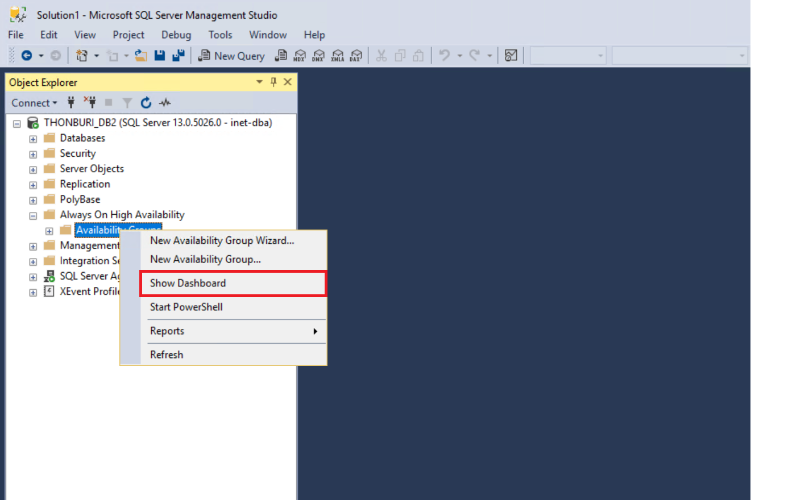

Figure 1 @SSMS: Conect with VTECAG to Show Dashboard.

* Availability group dashboard can show all status about AG for analyze issues of AG.

<ใส่รูป>

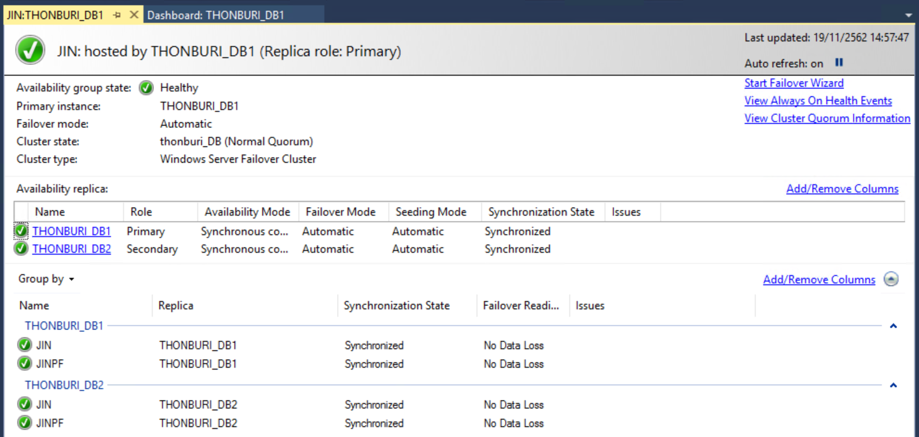

Figure 2 @SSMS: Dashboard, show detail about Availability group.

## **5.2 Check Status Availability Groups**

In availability groups dashboard check status replica, databases and AG logs.

1. Status replica in tab Availability replica column Synchronization State.

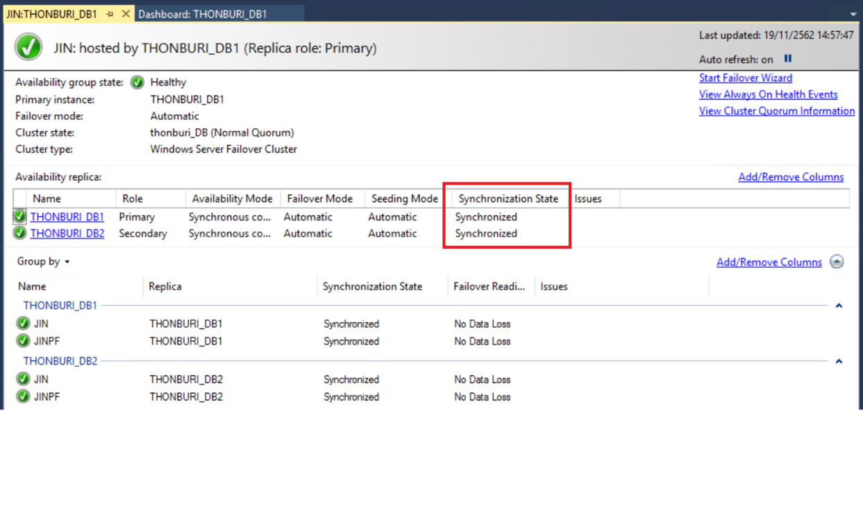

Figure 3 @SSMS: Show synchronization state in Availability replica.

Synchronization State

Indicates whether a secondary replica is currently synchronized with primary replica. The possible values are as follows:

Value: Not Synchronized

Description: The database is not synchronized or has not yet been joined to the availability group.

Value: Synchronized

Description: The database is synchronized with the primary database on the current primary replica, if any, or on the last primary replica.

Note: In performance mode, the database is never in the Synchronized state.

Value: NULL

Description: Unknown state. This value occurs when the local server instance cannot communicate with the WSFC failover cluster (that is the local node is not part of WSFC quorum).

1. Status databases in tab “Group by” column Synchronization State.

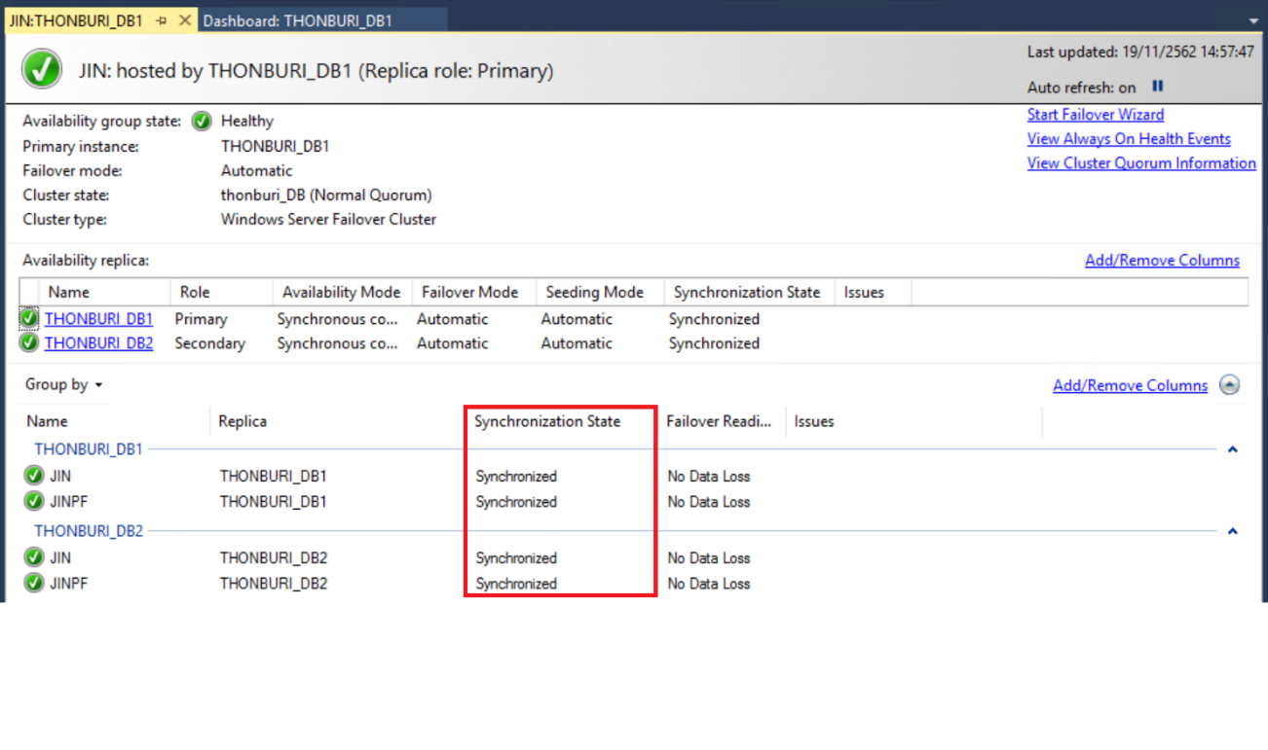

Figure 4 @SSMS: Show synchronization state in Group by.

Synchronization State

Indicates whether the availability database is currently synchronized with primary replica. The possible synchronization states are as follows:

Value: Synchronizing

Description: The secondary database has received the transaction log records for the primary database that are not yet written to disk (hardened).

Note: In asynchronous-commit mode, the synchronization state is always Synchronizing.

1. Log of Availability groups click View Always On Health events.

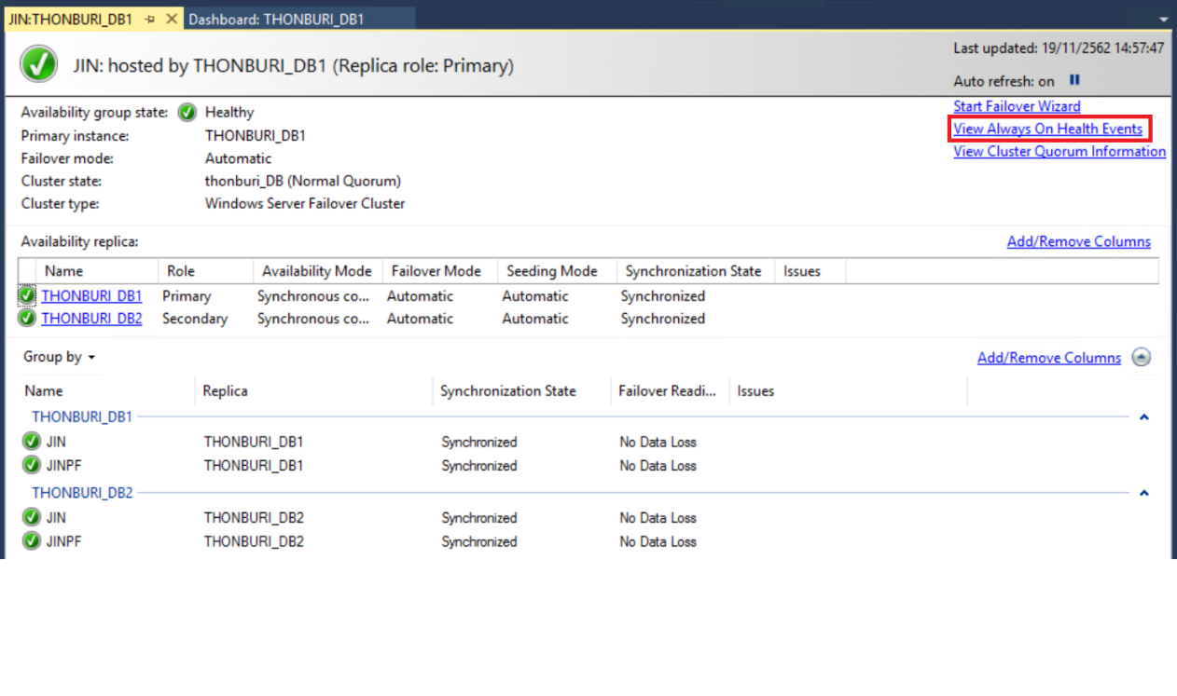

Figure 5@SSMS: 'View Always on Health Events’.

## **5.3 Failover Availability Group (Manual Failover in SSMS)**

- Connect to instance on primary node and expand folder tab Always On High Availability and expand Availability Groups right click Availability Groups name and select Failover.

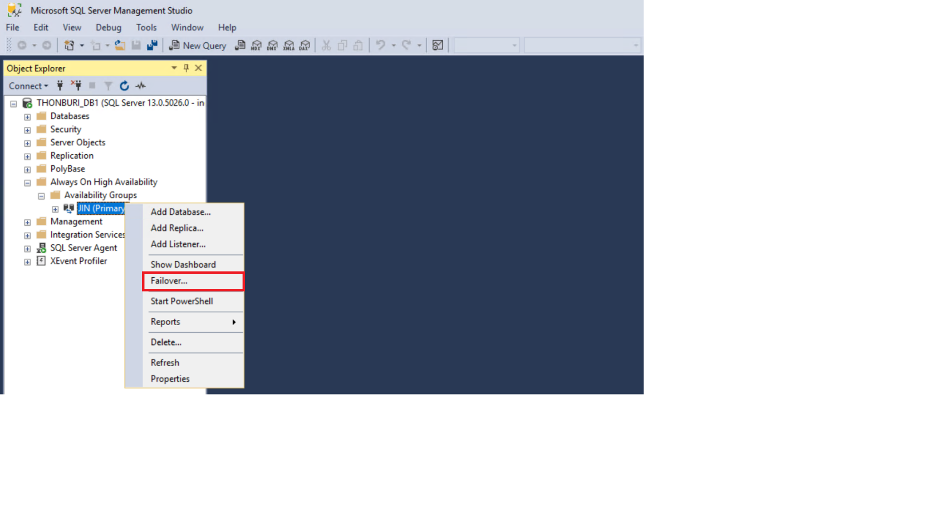

Figure 6 @SSMS: Select 'Failover...' to failover Primary to Secondary.

* In Failover Availability Group wizard click Next button.

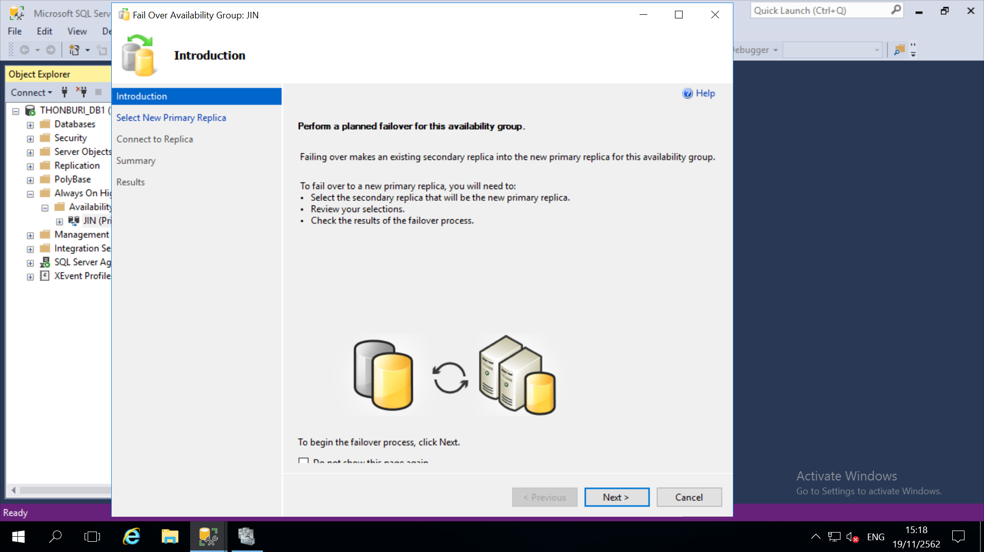

Figure 7 @SSMS: In Fail over Availability Group wizard.

* Check Box Choose new primary replica and click Next button.

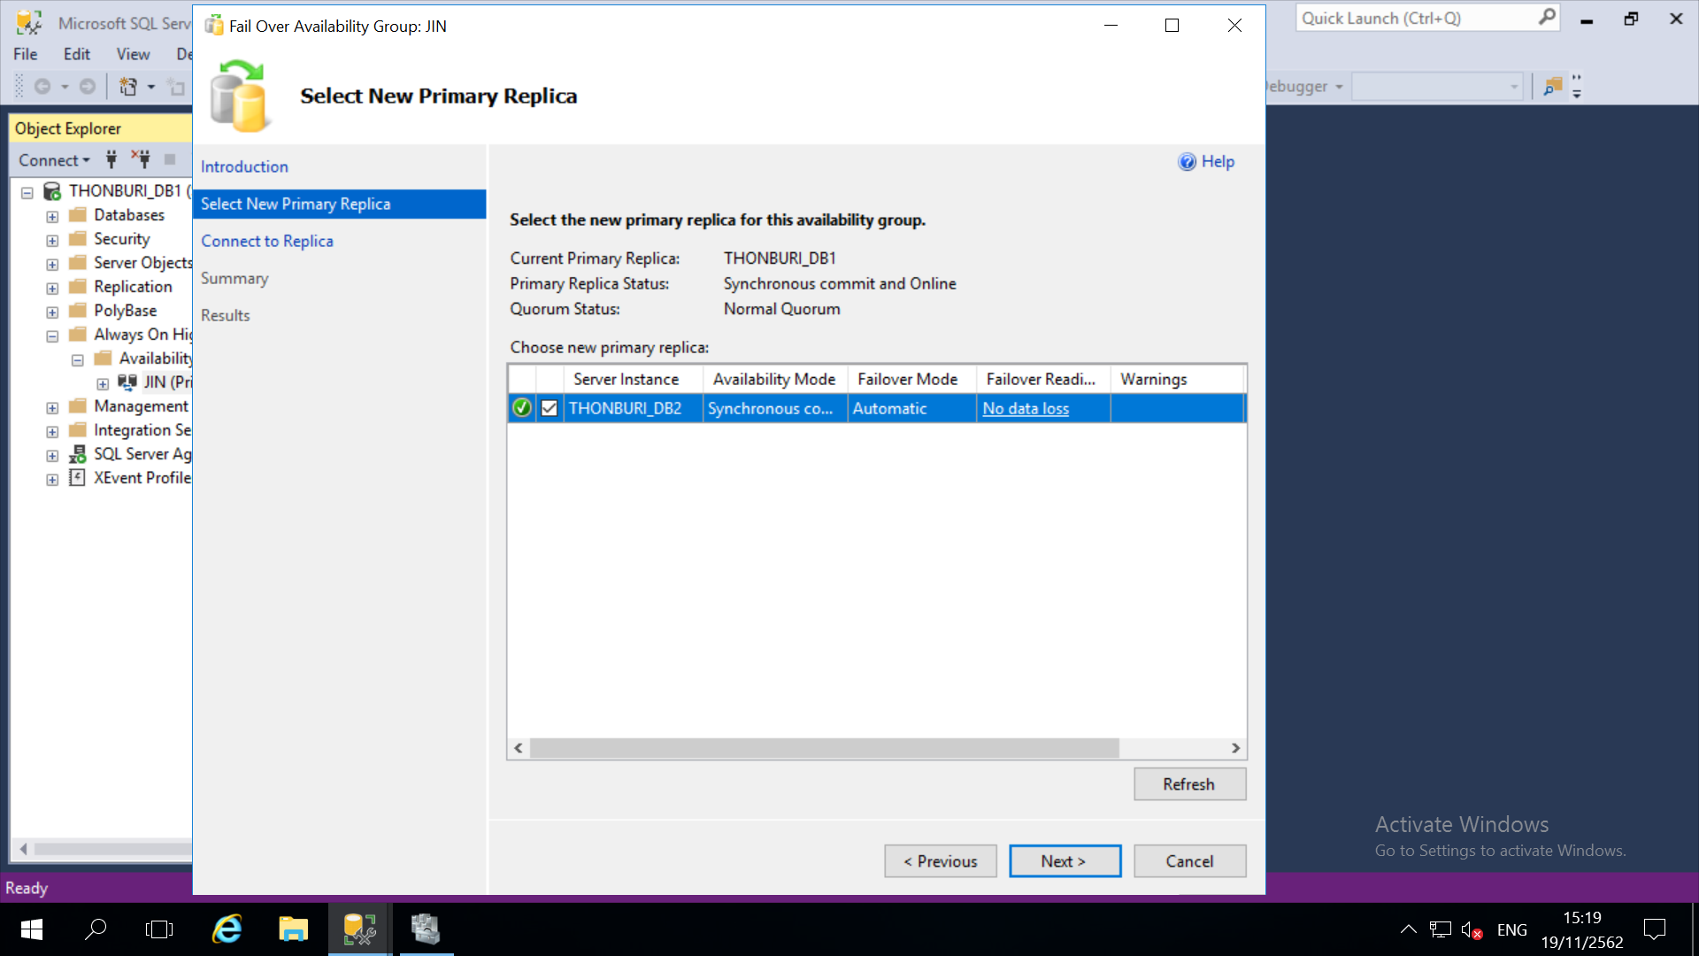

Figure 8 @SSMS: Select replica to failove.

* Click connect button choose option authenticate to secondary replica and connected if success click Next button.

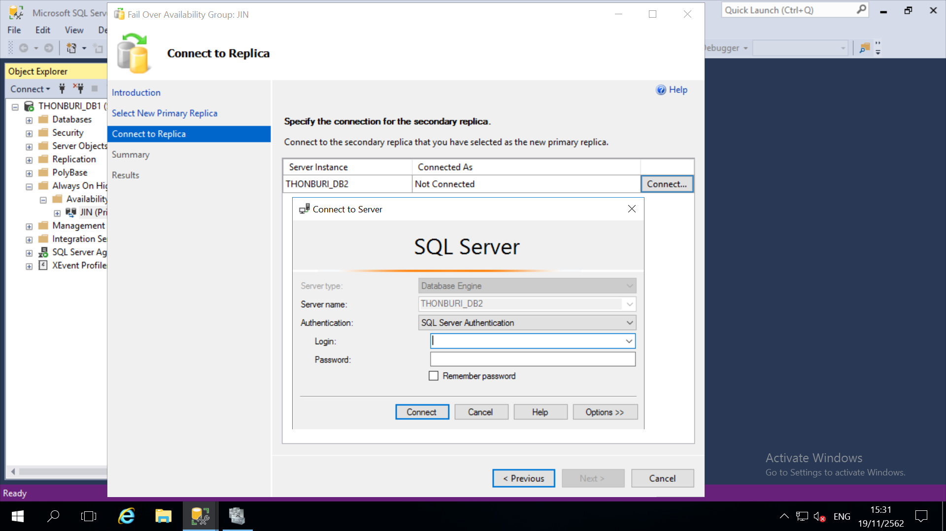

Figure 9 @SSMS: Connect to secondary replica.

* Check name new primary replica check failover Actions and check affected database if check completed click finish button for failover availability groups.

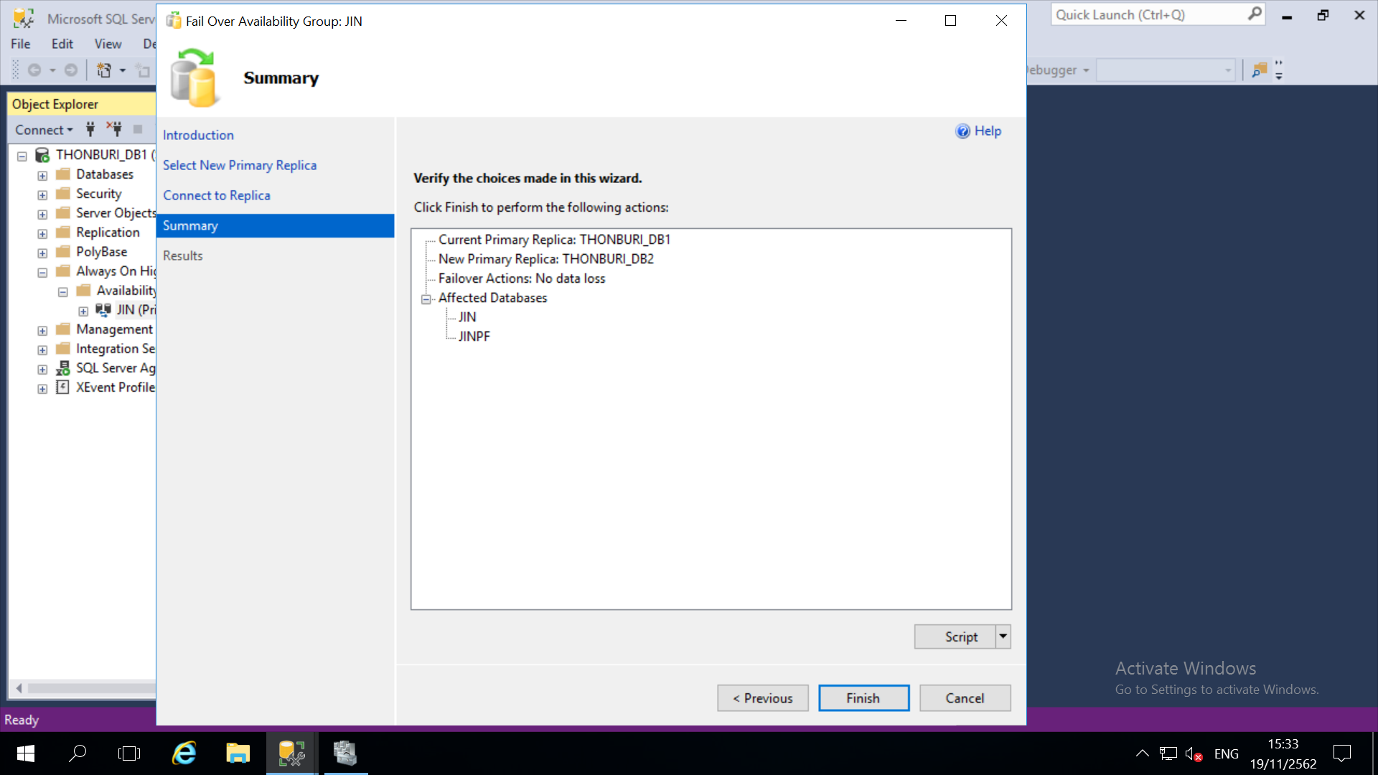

Figure 10 @SSMS: Check information for failover.

- Successfully.

# **6. Test Failover Availability Group**

## **6.1 Manual failover availability group**

* Result: Primary is <ใส่ชือ hostname node ที่เป็น primary roles>.

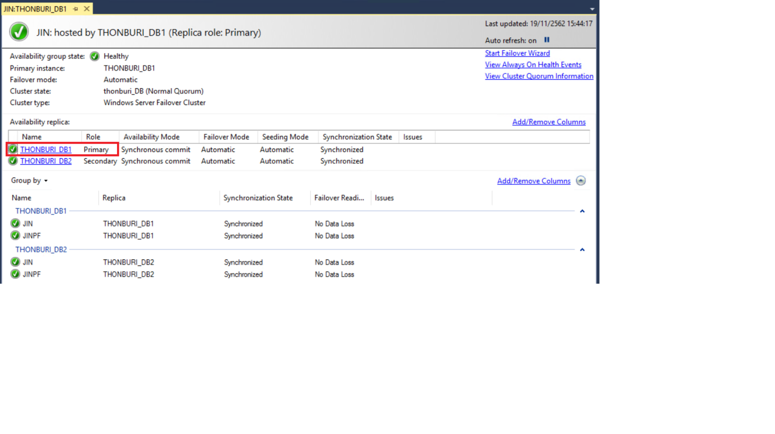

Figure 11 @SSMS: VTEC THONBURI _DB1 is primary.

* Manual failover to THONBURI_DB2.
* Result: Primary is THONBURI_DB2.

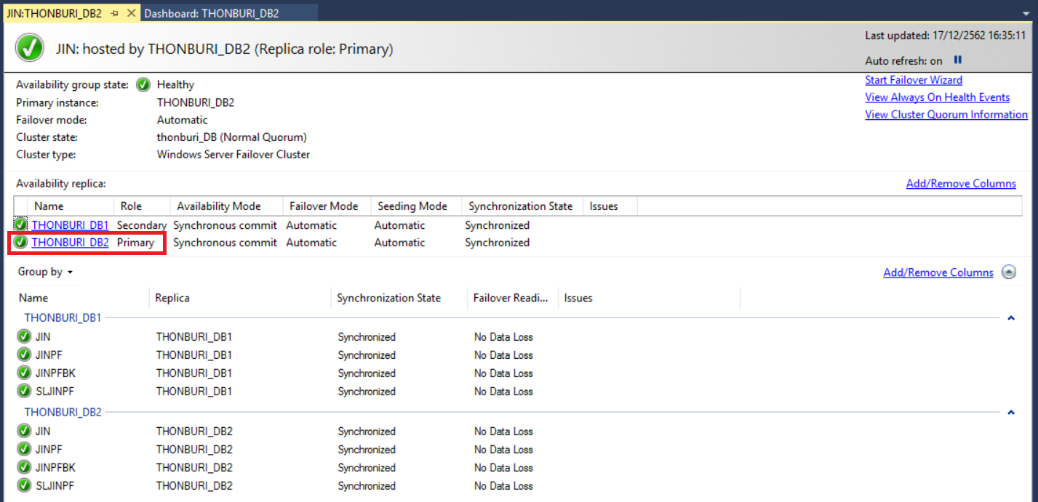

Figure 12 @SSMS THONBURI _DB2 is primary.

* Manual failover to THONBURI_DB1.
* Result: Primary is THONBURI_DB1.

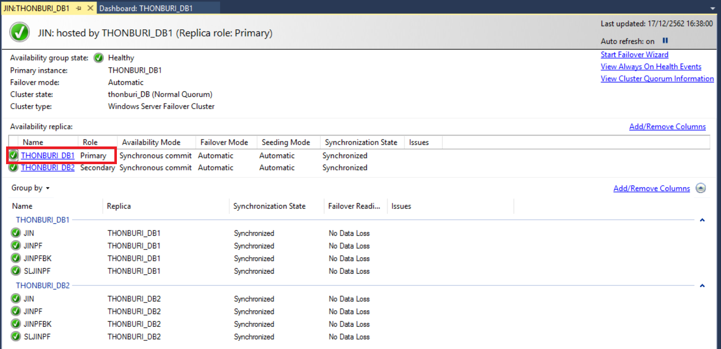

Figure 13 @SSMS: THONBURI _DB1 is primary.

# **7. Test connect to SQL Server**

## **7.1 Test connect database by SSMS on THONBURI_DB1**

|  |  |  |
| --- | --- | --- |
| **No.** | **Task** | **Status** |
| 1 | Connect to hostname (node1) by SQL Server authentication. | done |
| 2 | Connect to hostname with port (node1) by SQL Server authentication. | done |
| 3 | Connect to IP node1 by SQL Server authentication. | done |
| 4 | Connect to IP with port (node1) by SQL Server authentication. | done |
| 5 | Connect to Always on listener name by SQL Server authentication. | done |
| 6 | Connect to Always on listener name with port by SQL Server authentication. | done |
| 7 | Connect to Always on IP listener by SQL Server authentication. | done |
| 8 | Connect to Always on IP listener with port by SQL Server authentication. | done |

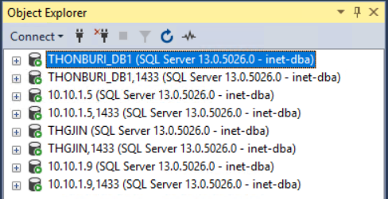

Figure 20 @SSMS: Connect database by ssms on VTEC THONBURI _DB1.

## **7.2 Test connect database by SSMS on THONBURI_DB2**

|  |  |  |
| --- | --- | --- |
| **No.** | **Task** | **Status** |
| 1 | Connect to hostname (node2) by SQL Server authentication. | done |
| 2 | Connect to hostname with port (node2) by SQL Server authentication. | done |
| 3 | Connect to IP node1 by SQL Server authentication. | done |
| 4 | Connect to IP with port (node2) by SQL Server authentication. | done |
| 5 | Connect to Always on listener name by SQL Server authentication. | done |
| 6 | Connect to Always on listener name with port by SQL Server authentication. | done |
| 7 | Connect to Always on IP listener by SQL Server authentication. | done |
| 8 | Connect to Always on IP listener with port by SQL Server authentication. | done |

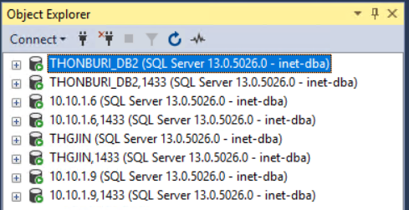

Figure 21 @SSMS: Connect database by ssms on THONBURI _DB2.

# **8. Windows Users**

## **8.1 On AD**

|  |  |  |  |
| --- | --- | --- | --- |
| **USER** | **LEVEL** | **PERMISSION** | **ROLE** |
| VTEC\sqlservice | OS, Window Authentication for SQL Server | Administrator, SYSADMIN | Customer |

## **8.2 On Local**

|  |  |  |  |
| --- | --- | --- | --- |
| **USER** | **LEVEL** | **PERMISSION** | **ROLE** |
| vtecsa | Authentication for SQL Server | SYSADMIN | Customer |

# **9. Schedule job database**

## **9.1 Backup & Retention**



* Backup full on Saturdays at 12:00AM
* Backup differential daily at 12:00PM except Saturday
* Backup log every 2 hour
* Retention on Saturdays at 01:00AM

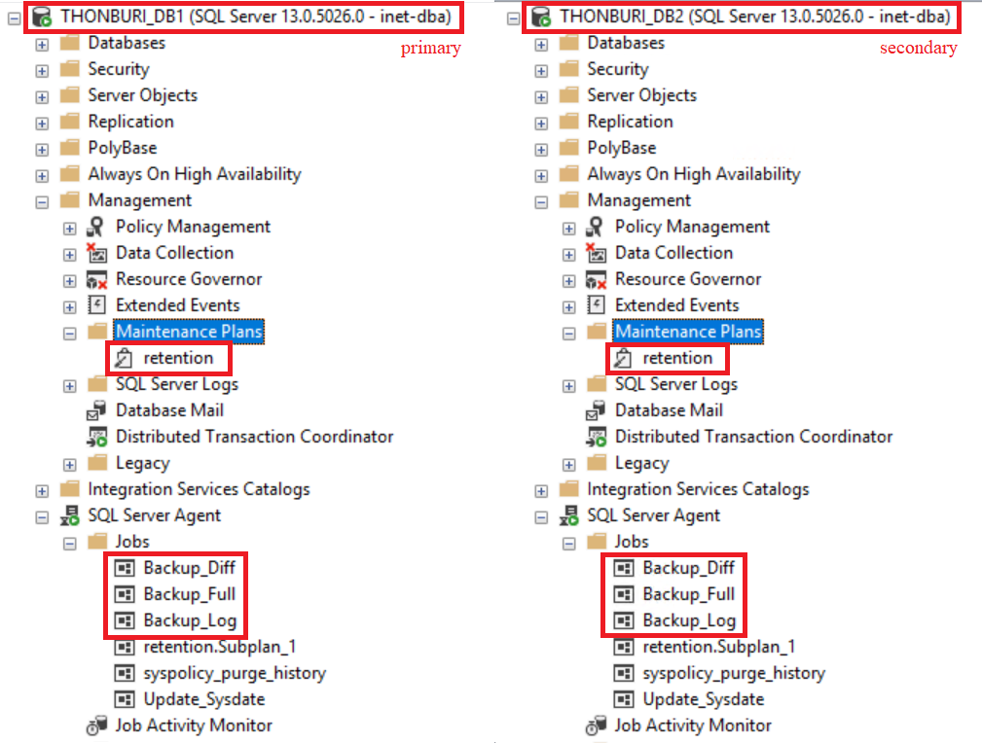

Figure 22 @SSMS: Schedule backup on instance(2node)

|  |  |
| --- | --- |
| ผู้ตรวจสอบการใช้งาน | |
| ผู้ขอรับบริการ | บริษัท ไอเน็ต แมเนจด์ เซอร์วิสเซส จำกัด (มหาชน) |
| (………………………………………………..…………)  <ชื่อลูกค้า เป็นทางการ> | (………………………………………………..…………)  ส่วนงาน Database Management Services |